2023 DONGGUK UNIVERSITY
INTERNATIONAL SUMMER SCHOOL

COURSE TITLE | Global Capstone Design
DATES | June 26, 2023 – July 12, 2023
COURSE TIMES | 14:00-17:00
CREDIT HOURS | 3 credits
PROFESSOR | - Name : Sungbum Jun - Email : sbjun@dgu.ac.kr
COURSE DESCRIPTION | The purpose of the Global Capstone Design (GCD) is for the students to apply the theoretical knowledge acquired during this summer semester. During the project, students engage in the entire process of solving realistic problems provided by industry-leading Korean companies. Both the problem statements and the datasets originate from domains similar to those that students might typically encounter within industry or academic research.  This GCD is based on a capstone project with collaboration between international students including from Finland and South Korea. Depending on the complexity of the project, students will work in small teams (maximum 6 members) on a problem statement, typically specified by a faculty or industry. Each project team is supervised by faculty or project coaches assigned from industry sponsors. Students also will have a tour of headquarters for hands-on experience and special lecture series.  The topic is provided from both South Korean wireless telecommunications company (SK Telecom) and battery manufacturing company (LG Energy Solution) in South Korea. The potential topic (but are not limited to) is as follows:  - Service Ideation for AI Speaker called Nugu  - Service Ideation for personalized AI Software called A. (A dot)  - Business Development for solving environmental issues such as net zero carbon, urbanization, carbon neutrality  - Solutions for improving supply chain visibility and transparency considering environmental risks  The basic philosophy of GCD is a problem-based learning (PBL), which develops problem-solving techniques from experiences. The major goals of GCD are as follows:  - Define the problems properly from the real-world dataset  - Identify possible alternatives for the defined problem  - Elaborate the approach with other students  - Provide detailed solutions to practitioners and receive feedback  Project Description  1. AI Service Ideation  SK Telecom has launched an AI assistant service by equipping its AI speaker Nugu Candle, which supports both Korean and English languages, through collaboration with Amazon. Customers can use the wake word “Aria” to initiate Nugu services in Korean, and “Alexa” to enjoy Alexa’s services in English. Both Nugu and Alexa support basic features like weather, news, chitchat and calendar. Korean content like Flo (music streaming service) and Potbbang (audio streaming service) can be accessed via Nugu, while foreign content such as TuneIn can be enjoyed via Alexa.  In addition to Nugu, SK Telecom also upgraded its artificial intelligence service called A. (A dot). by adopting long-term memory technology to enable the AI secretary to remember its owner's crucial information for a long time. Users can form a strong friendship with the AI service as it can engage in a conversation without any difficulties even when humans bring back their old memories. A. is a time-saving service that intelligently handles cumbersome tasks that consumers may face while using smartphones. The AI service also recommends and plays music or videos that match users' preferences. Users can decorate their own characters and talk to them through voice or text. Various services essential for daily life such as music, over-the-top (OTT) content, transportation, calendar, phone, and text messages can be conveniently connected to the AI secretary.  2. Business Development for solving Environmental Issues  Environmental, Social and Governance (ESG) is a framework designed to be embedded in an organization’s strategy that considers the needs and opportunities to create value for all the stakeholders. From consumers to investors, more people are choosing companies that prioritize environmental, social and governance concerns. In this context, a great start-up idea could be to develop an environmentally friendly business idea that is both profitable and helps our environment.  For example, supply chain transparency requires companies to know what is happening upstream in the supply chain and to communicate this knowledge both internally and externally. To address environmental issues, a new business idea for a retail services company could use blockchain to connect inventory, information and financial flows, allowing companies to track the progress of a transaction.  A team comprised of capstone students, advised by the instructor in conjunction with a technical coach from the company, employ the dataset to develop new business ideas or solutions and propose customized marketing strategies.
  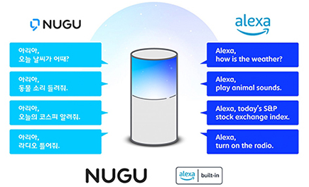 | 
  AI speaker Nugu | Personalized AI Software A. (A dot)
  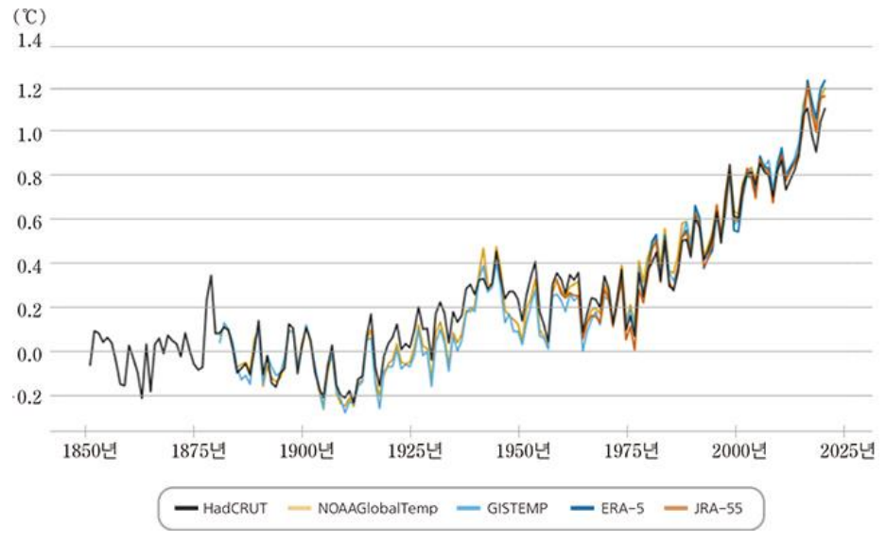 | 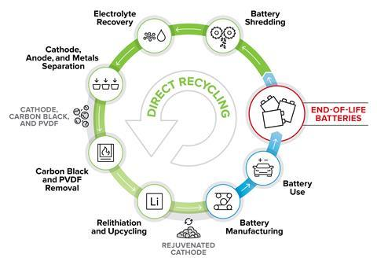
  Earth Average Temperature | Battery Recycling Process
SCHEDULE | DAY 1 (6/26) | Introduction
SCHEDULE | DAY 2 (6/27) | Problem Description – AI Service with IoT devices
SCHEDULE | DAY 3 (6/28) | Problem Description – Environmental Issues
SCHEDULE | DAY 4 (6/29) | SK Telecom Headquarter Tour
SCHEDULE | DAY 5 (6/30) | Problem Definition and Ideation
SCHEDULE | DAY 6 (7/3) | Mid-term Presentation
SCHEDULE | DAY 7 (7/4) | Design of Solution Approaches
SCHEDULE | DAY 8 (7/5) | Data Analysis for Concretization of Ideas
SCHEDULE | DAY 9 (7/6) | Peer Review
SCHEDULE | DAY 10 (7/7) | Preparation of Final Presentation
SCHEDULE | DAY 11 (7/10) | Discussion, Feedback, and Comments
SCHEDULE | DAY 12 (7/11) | Final Presentation (1) – Topics related to AI Service
SCHEDULE | DAY 13 (7/12) | Final Presentation (2) – Topics related to Environmental Issues
REFERENCE | There is no required textbook for the course. Instructors can recommend various references (including texts and journal articles) particular to topics of interest.
EVALUATION | The evaluation of this course is based on the following criteria:  - Attendance and Participation  - Mid-term Presentation  - Final Presentation  - Evaluation of Practitioners  - Peer-evaluation -  2)-4): The tabulated results will be reviewed by the instructor.  5): Students will complete an anonymous survey.
ASSIGNMENT | - Ideation and One-page Executive Summary  - Mid-term Presentation  - Final Presentation  - Attendance and Peer Review

